We think it is time we had a new skate area.
What do you think?
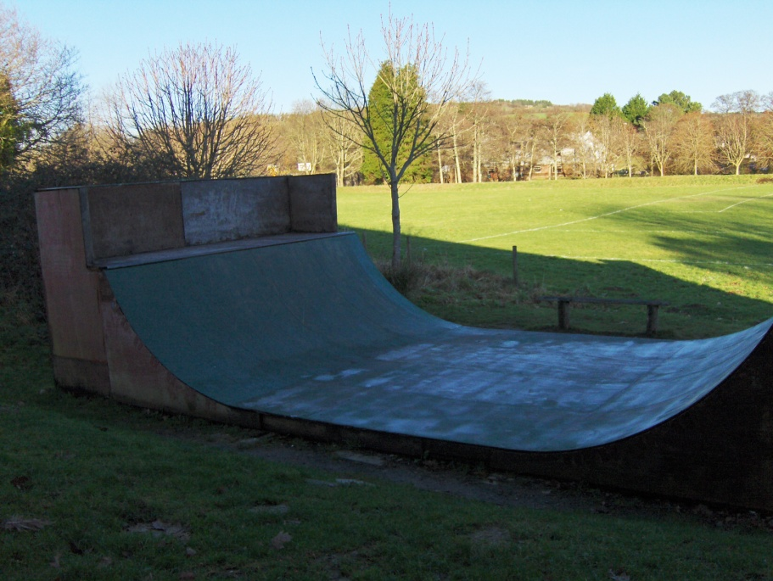

The Friends of Lostwithiel Skate ramp are 3 people who have been looking after the ramp for years by mending it and keeping it safe to use.
Our skate ramp has been wonderful for 13 years but it is now very old and worn out and will be dismantled at the end of Summer 2011.
If enough young people and parents in Lostwithiel and nearby villages want us to try and raise the money for a new project, we need lots of evidence to prove that you really want it and need it because a couple of decent jumps cost the same as a 2 bedroom flat.
We would also like some new people to come forward and help us raise these funds.
So, PLEASE answer the questions on the back of this page and deliver it to Lostwithiel library, Lostwithiel Community Centre or 22, Fore Street, Lostwithiel, PL22 0BL by 31st June 2011

It doesn’t matter how old you are, you can still answer the questions overleaf.

Q1 Are you male or female?
Please tick Q 1 to Q6 for each person taking the survey and also fill Q7 to Q11 with comments made by everyone in your family, house, class or group.
Q2 How old are you?
Q3 What do you use the ramp for? (tick any you do)
- Skateboarding
- Scooter
- Rollerblade
- BMX bike
- I don’t use it but I have some opinions. (Go to Q5 and Any Comments?)
Q4 How often do you use the ramp? (tick one)
- Every day if I can
- Most days
- About once a week
- About once a month
- Less often
Q5 Where do you live? (just the town or village will do)
Q6 How do you get to the ramp ? (tick all you use)
- Walk or skate or cycle
- Bus
- Train
- By car
Q7 What is good about the ramp?
Q8 What is bad about the ramp?
Q9 How would your life be better if we built something to replace it?

Q10 If you think your life would be worse, please tell us why.

Q12 What are you prepared to do to help raise money? E.g. sponsored skate, car washing, donate raffle prizes, organise fund raising activities, collect evidence?
Q11 ANY COMMENTS

